IntelliData - Agentic AI Based Data Intelligence & Governance Platform

AD23731 Foundations of Agentic AI - Mini-Project

Submitted by

Kartickeeyaan M | 231501074
Lokesh R | 231501087
Mano Prasad V | 231501095

Department of Artificial Intelligence and Machine Learning



(An Autonomous Institution, Affiliated to Anna University, Chennai) SEPTEMBER 2026

BONAFIDE CERTIFICATE

Certified that this mini-project report “IntelliData - Agentic AI Based Data Intelligence & Governance Platform” is the bonafide work of “Kartickeeyaan M (231501074), Lokesh R (231501087), Mano Prasad V (231501095)” VII Semester, B.Tech. Artificial Intelligence and Machine Learning Department in partial fulfilment of the requirements of the course AD23731 – Foundations of Agentic AI during the Academic Year 2026 – 2027.

Faculty in-charge

Submitted to mini-project viva voce examination held on: ………………………

INTERNAL EXAMINER EXTERNAL EXAMINER

TABLE OF CONTENTS

S.NO | TITLE | PAGE.NO
 | ABSTRACT
 | LIST OF TABLES
 | LIST OF FIGURES
1 | INTRODUCTION  - Background and Motivation  - Need for Agentic AI  - Project Objectives | 1
2 | PROBLEM STATEMENT  - Problem Definition  - Business and Real-World Context | 4
3 | USER AND STAKEHOLDER ANALYSIS | 6
4 | PROPOSED AGENTIC AI SOLUTION  - Overall Solution  - Key Features  - Agent-Based Approach | 8
5 | DATASET / KNOWLEDGE SOURCES  - Dataset Description  - Knowledge Sources  - Data and Governance Knowledge | 11

6 | TOOLS AND TECHNOLOGIES USED  - Programming and Frameworks  - AI and Data Processing Tools  - Development and Testing Tools | 13
7 | AGENT ARCHITECTURE  - Agent Components  - Tools  - Memory and State  - Reasoning Flow  - Agent Interactions | 15
8 | AGENT WORKFLOW AND ORCHESTRATION | 19
9 | AGENTIC RAG IMPLEMENTATION | 22
10 | SYSTEM IMPLEMENTATION | 24
11 | EVALUATION AND RESULTS | 28
12 | COMPARISON, INNOVATION AND SCALABILITY | 31
13 | CONCLUSION AND FUTURE WORK | 34
14 | REFERENCES | 35

ABSTRACT
IntelliData is an Agentic AI Based Data Intelligence & Governance Platform designed to make data preparation and analysis more efficient, controlled, and easier to track. Real-world datasets often contain missing values, duplicate
information, inconsistent data types, and outliers. Handling these issues manually can take considerable time and may make it difficult to reproduce or explain the changes made to a dataset. IntelliData addresses this problem by combining automated data analysis with human approval and governance.
The system uses a Supervisor Agent to coordinate specialized agents for data intake, quality assessment, cleaning planning, cleaning execution, visualization, ML readiness, insight generation, and report generation. Each agent performs a specific task within the workflow.
The Governed Tool Registry allows agents to use only registered tools and prevents uncontrolled tool execution. This provides a structured approach to automating common data-analysis activities while keeping the workflow organized and traceable.
A major part of IntelliData is Human-in-the-Loop (HITL) governance. Instead of directly changing the dataset, the system first creates cleaning proposals with risk levels. The system preserves the original dataset, creates
new versions after approved changes, supports rollback, and maintains an audit trail. This allows users to understand and control important changes made during the analysis process.
The platform also supports AI-assisted insight generation using statistical information such as missing percentages, distributions, quantiles, outliers, and
correlations instead of sending raw data rows to the AI service. Google Gemini can be used when available, while a local deterministic fallback is provided when it is unavailable.
Overall, IntelliData combines Agentic AI, Human-in-the-Loop approval, tool governance, dataset versioning, privacy-aware AI usage, and auditability to reduce repetitive data-analysis work while keeping important decisions under human control.

LIST OF TABLES

S.NO | TABLE NAME | PAGE NO
1. | Comparison with Baseline | 31

LIST OF FIGURES

S.NO | FIGURE NAME | PAGE NO
1. | High-Level IntelliData Solution Flow | 8
2. | IntelliData Agent Architecture and Governance Flow | 15
3. | Quality Assessment and Dataset Distribution | 26
4. | Agent Governance Hub and Multi-Agent Workflow | 26
5. | Human-in-the-Loop Review of a High-Risk Cleaning Proposal | 26
6. | Interactive Visualization and Correlation Analysis | 27
7. | ML Readiness Assessment and Baseline Recommendations | 27
8. | Completed Agent Workflow with Dataset Version Tracking | 27

Introduction

Background and Motivation
Data is an important part of modern applications, business decisions, and machine learning systems. However, real-world datasets are rarely ready for direct use. They may contain missing values, duplicate records, outliers, inconsistent data types, and other quality issues. Before analysis or machine learning, these problems need to be identified and handled carefully.
Traditional data preparation often requires analysts to manually inspect datasets, perform cleaning operations, create visualizations, and check whether the data is suitable for machine learning. This process can be repetitive and time-consuming. It can also become difficult to reproduce or audit when many changes are made during the analysis.
AI assistants can reduce some of this effort by generating summaries, recommendations, and insights. However, using AI alone introduces important concerns. An AI system may suggest an unsafe data transformation, make a causal claim from a simple correlation, or send sensitive raw records to an external AI service. Therefore, automation needs to be combined with proper control and traceability.
IntelliData — An Agentic AI Based Data Intelligence & Governance Platform addresses these issues by combining agent-based workflow orchestration with governed data-processing tools. The platform can inspect datasets, assess data quality, create cleaning proposals, perform exploratory analysis, check ML readiness, generate AI-based hypotheses, and prepare a governance report.

Human users remain involved at important decision points through Human-in-the-Loop (HITL) approval. The system also maintains dataset versions and an audit trail so that changes can be reviewed and rolled back when required. This makes the platform focused not only on automation, but also on controlled and traceable data intelligence.

Need for Agentic AI

A normal automated data pipeline generally follows a fixed sequence of operations. It performs predefined tasks but has limited ability to change its actions based on the findings from earlier steps.
The proposed system uses an agentic approach to make the workflow more flexible. The Supervisor Agent manages the overall process and coordinates specialized agents according to the current workflow state. For example, after quality analysis, the Cleaning Planner Agent can create cleaning proposals based on the detected issues. The workflow then pauses for human approval before any approved cleaning action is executed.
This approach is useful because different parts of the data investigation require different types of analysis. The Intake Agent focuses on dataset structure, the Quality Agent focuses on data quality, the ML Readiness Agent checks machine learning requirements, and the Insight Agent produces structured hypotheses.
Agentic AI therefore provides a way to combine autonomous workflow execution with controlled human decisions.

Project Objectives
The main objectives of IntelliData are:
    - To automate dataset intake, profiling, quality assessment, and exploratory analysis.
    - To use specialized agents for different stages of the data intelligence workflow.
    - To provide governed tools for data processing and prevent unauthorized tool execution.
    - To keep humans involved in important cleaning and export decisions through HITL approval.
    - To maintain immutable dataset versions and a complete audit trail.
    - To provide ML-readiness diagnosis and AI-generated business hypotheses.
    - To protect data privacy by sending only bounded statistical information to Gemini instead of raw dataset rows.
    - To provide a final analysis-ready dataset, human-reviewed insights, and an HTML governance report.

Problem Statement and Business Case

Problem Definition
Real-world datasets often contain missing values, duplicate records, outliers, inconsistent data types, and other quality issues. These problems can affect the reliability of data analysis and machine learning results.
The traditional process of preparing a dataset requires users to manually inspect the data, identify quality issues, perform cleaning, create visualizations, and check ML readiness. This process can be repetitive and difficult to reproduce or audit.
There is also a risk when data-processing tasks are fully automated. An automated system may make changes without user approval, provide unsupported AI conclusions, or make it difficult to understand what happened to the original dataset.
The problem addressed by this project is therefore:

How can data preparation and analysis be automated using Agentic AI while keeping data transformations controlled, reviewable, versioned, and traceable?
IntelliData addresses this problem through a governed multi-agent workflow. The system allows agents to analyze the dataset and propose actions, while important operations such as cleaning, rollback, and export require explicit approval.

Business and Real-World Context

Data analysts and data scientists spend considerable time preparing datasets before performing analysis or building machine learning solutions. Business users may also need understandable summaries and insights without directly working with code.
IntelliData is designed to support these different users by providing a structured workflow for dataset analysis. Data analysts can inspect and clean datasets, business users can review plain-language summaries and hypotheses, and students or researchers can use the system to perform reproducible data preparation with traceability.
The platform is especially useful in situations where data changes need to be controlled and explained. For example, when a cleaning proposal is created, the user can review the proposed action, modify its parameters, approve it, or reject it. Approved changes are stored as new dataset versions, while the original dataset remains preserved.
This approach can be useful in real-world data workflows where data quality, human review, privacy, and auditability are important. The final output includes an analysis-ready dataset, quality information, EDA results, ML-readiness diagnosis, reviewed AI insights, and an HTML governance report containing the audit trail.

User and Stakeholder Analysis

Target Users
IntelliData is designed for users who work with datasets and need a structured way to prepare, analyze, and review data.

Data Analysts and Data Scientists
Data analysts and data scientists can use IntelliData to quickly profile datasets, identify quality issues, review cleaning proposals, perform EDA, and check ML readiness. The governed workflow allows them to review important actions before they are applied.

Business Users and Decision Makers
Business users can use the platform to understand dataset summaries and AI-generated business hypotheses without writing code. The system presents findings in a structured and understandable form.

Students and Researchers
Students and researchers can use IntelliData to learn and perform structured data preparation. Dataset versioning and the audit trail also make the workflow easier to reproduce and review.

Stakeholder Identification
The main stakeholders of the system are:
- Data Analysts / Data Scientists – Use the platform for data preparation, quality assessment, EDA, and ML-readiness analysis.
- Business Users / Decision Makers – Review summaries and business hypotheses generated from the dataset.
- Students / Researchers – Use the platform for learning, experimentation, and reproducible data preparation.

- Project Administrators or Reviewers – Can examine the audit trail, dataset versions, approvals, and generated governance report.

User Requirements
The main user requirements identified for IntelliData are:
    - Simple dataset upload – Users should be able to upload CSV or Excel files through the Streamlit interface.
    - Dataset inspection – The system should provide information about schema, empty columns, identifier columns, and date-like values.
    - Data quality assessment – Users should receive quality scores and warnings for issues such as missing values, duplicates and outliers.
    - Controlled cleaning – Users should be able to review, edit, approve, or reject cleaning proposals.
    - Data versioning – Every approved transformation should create a new dataset version while preserving the original dataset.
    - Exploratory analysis – Users should receive useful distributions, correlations, and recommended visualizations.
    - ML-readiness diagnosis – The system should identify issues such as target leakage, class imbalance, scaling, and encoding requirements.
    - AI-assisted insights – Users should receive structured hypotheses with confidence levels without unsupported causal claims.
    - Auditability – Workflow events, approvals, transformations, and AI outputs should be recorded in the audit trail.
    - Controlled export – Final reports and datasets should only be exported after the required human approval.

Proposed Agentic AI Solution

Overall Solution
IntelliData is a multi-agent, governed AI platform designed to automate the data intelligence workflow while keeping important decisions under human control.
The system starts with a user-uploaded CSV or Excel dataset. The Supervisor Agent manages the workflow and coordinates specialized agents for data intake, quality assessment, cleaning, visualization, ML readiness, insight generation, and report generation.
The workflow does not allow agents to directly perform unrestricted operations. Instead, their capabilities are provided through a Governed Tool Registry containing registered deterministic tools. Sensitive operations require approval before execution.
The system also maintains dataset versions and an immutable audit trail. This allows users to understand what changes were made, when they were made, and which decisions led to those changes.
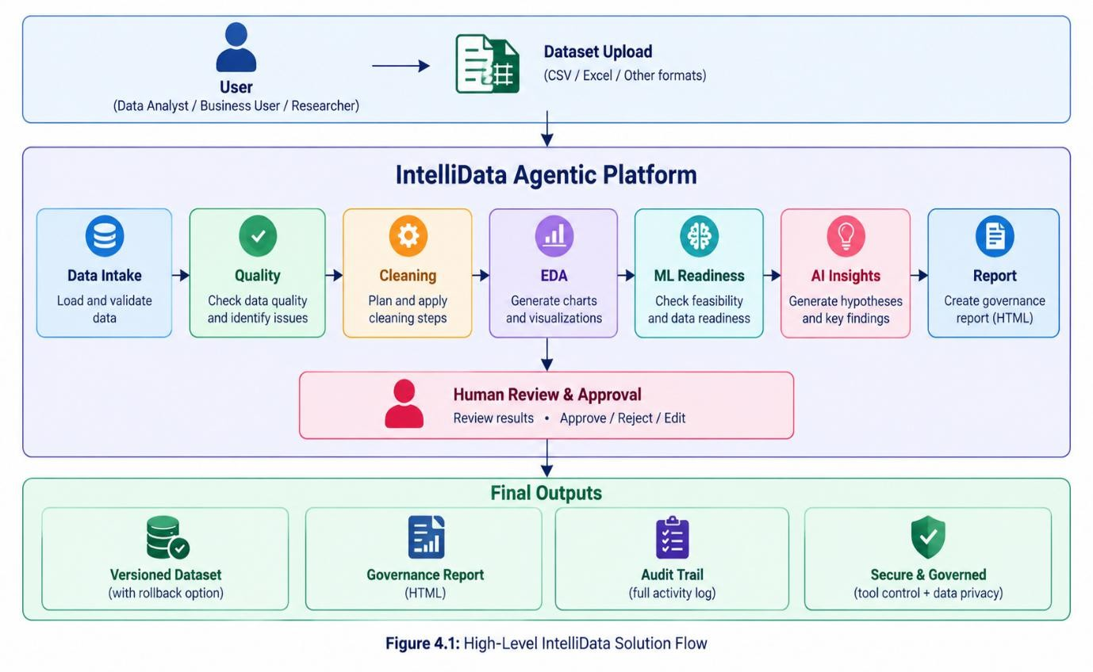

Key Features
The main features of IntelliData are:
- Dataset Intake – Validates and inspects uploaded datasets.
- Data Quality Assessment – Measures completeness, duplicate rate, type consistency, and IQR outliers.
- Risk-Rated Cleaning Proposals – Creates cleaning proposals with low, medium, or high risk levels.
- Human-in-the-Loop Approval – Users can approve, reject, or edit proposals before execution.
- Governed Tool Registry – Only registered tools can be used by agents.
- Data Versioning – Approved transformations create new dataset versions while preserving the original dataset.
- Rollback – Users can restore a dataset to its parent version.
- Visualization Recommendations – Suggests semantically safe charts.
- ML Readiness – Checks target leakage, class imbalance, scaling, and encoding needs.
- AI Business Insights – Generates structured hypotheses with confidence levels.
- Privacy Boundary – Gemini receives bounded statistics instead of raw dataset rows.
- Audit Trail – Records important workflow and approval events.
- Governance Report – Produces an HTML report containing findings and the audit trail.

Agent-Based Approach
The system divides the complete data intelligence process into specialized agents.
The Supervisor Agent manages the overall workflow and controls transitions between agents. The Intake Agent performs read-only dataset inspection, while the Quality Agent identifies and scores data quality issues.
The Cleaning Planner Agent converts quality findings into risk-rated proposals. These proposals cannot be executed until the user provides approval. The Cleaning Executor Agent then applies only approved proposals through registered deterministic tools and creates a new dataset version.
After cleaning, the Visualization Agent recommends suitable charts and the ML Readiness Agent evaluates the dataset for machine learning. The Insight Agent generates structured hypotheses, and the Report Agent compiles the final findings and audit information into an HTML governance report.
This structure allows the platform to combine automation, specialized agent responsibilities, governed tool execution, and human review in a single workflow.

Dataset / Knowledge Sources

User-Uploaded Datasets
IntelliData works with datasets uploaded by the user through the Streamlit interface. The supported input formats are CSV and Excel files. Before processing, the uploaded file is validated for its file extension and size. A sample workspace using the Titanic-Dataset.csv file is also available for demonstration.
The uploaded dataset is the main source used throughout the workflow. The system derives information such as:
- Column names and data types
- Cardinality
- Missing-value percentage

- Quantiles
- IQR-based outliers
- Data distributions
- Pearson correlations
These derived statistics are used for data quality assessment, EDA, ML-readiness analysis, and AI-generated insights.

Derived Statistical Knowledge
The system does not need to send complete raw datasets to the AI model. Instead, relevant statistical information is derived from the active dataset.
This includes column profiles, missing percentages, quantiles, outlier information, distributions, and correlation values. These summaries provide the information required for analysis while supporting the project's privacy boundary.

Governance Knowledge
The platform also maintains information created during the workflow. This includes cleaning proposals, approval decisions, risk levels, dataset versions, and immutable audit events.
The dataset version graph records versions such as v0, v1, and v2, while the audit trail records important workflow events. Together, these sources provide the governance information needed to understand how the dataset changed during processing.

Knowledge Flow
The overall data and knowledge flow can be summarized as:
User Dataset → Statistical Analysis → Quality and EDA Findings → Agent Decisions → Human Approval → Dataset Versioning → AI Insights → Governance Report
This allows IntelliData to use both dataset-derived information and workflow governance information throughout the agentic data intelligence process.

Tools and Technologies Used

Application and Programming Language Python 3.12
Python 3.12 is the core programming language used to develop IntelliData. It is used for the agents, workflow management, data-processing tools, and supporting application logic.

Streamlit
Streamlit is used to build the user interface of the platform. It provides the multi-page application, Agent Governance Hub, dataset upload interface, approval controls, workflow status, and other user interactions.

Data Processing and Machine Learning

Pandas
Pandas is used for dataset loading, profiling, quality checks, and data transformations. It also supports the creation and management of different dataset versions during the cleaning workflow.

Scikit-learn
Scikit-learn is used for ML-readiness diagnostics and baseline algorithm suggestions. The platform focuses on diagnosing whether the dataset is suitable for machine learning rather than performing unauthorized automatic model training.

AI Model Google Gemini API
Google Gemini is an optional AI service used for executive summaries and structured hypotheses. The system can work without Gemini by using a local deterministic fallback based on Pearson correlations.

Orchestration and Governance Supervisor and Specialized Agents
The Supervisor Agent and specialized agents manage the workflow using defined states and approval checkpoints. This provides the agentic structure of the platform.

Governed Tool Registry
The Tool Registry controls which tools can be used by the agents. Only registered deterministic tools are allowed, and unknown tool names are rejected. Sensitive tools such as cleaning execution, rollback, and dataset export require approval.

Visualization

Plotly
Plotly is used to create interactive distributions, correlations, and recommended charts. The Visualization Agent uses these capabilities while applying semantic rules to avoid inappropriate aggregations.

Testing and Deployment Pytest and Ruff
Pytest is used for automated testing, including the governance tests. Ruff is used for code linting and maintaining code quality. Dependency integrity is also checked using pip check.

Docker and GitHub Actions
Docker is used for containerized deployment, while GitHub Actions supports the CI workflow. These tools help maintain a consistent development and deployment process.

Agent Architecture

Overview
IntelliData uses a multi-agent architecture in which different agents are responsible for specific stages of the data intelligence workflow. The Supervisor Agent coordinates these agents and controls the movement of the workflow between different stages.
The architecture also includes a Governed Tool Registry, workflow state, dataset versions, HITL approval checkpoints, and an audit trail. This allows the system to automate data analysis while keeping important operations under human control.

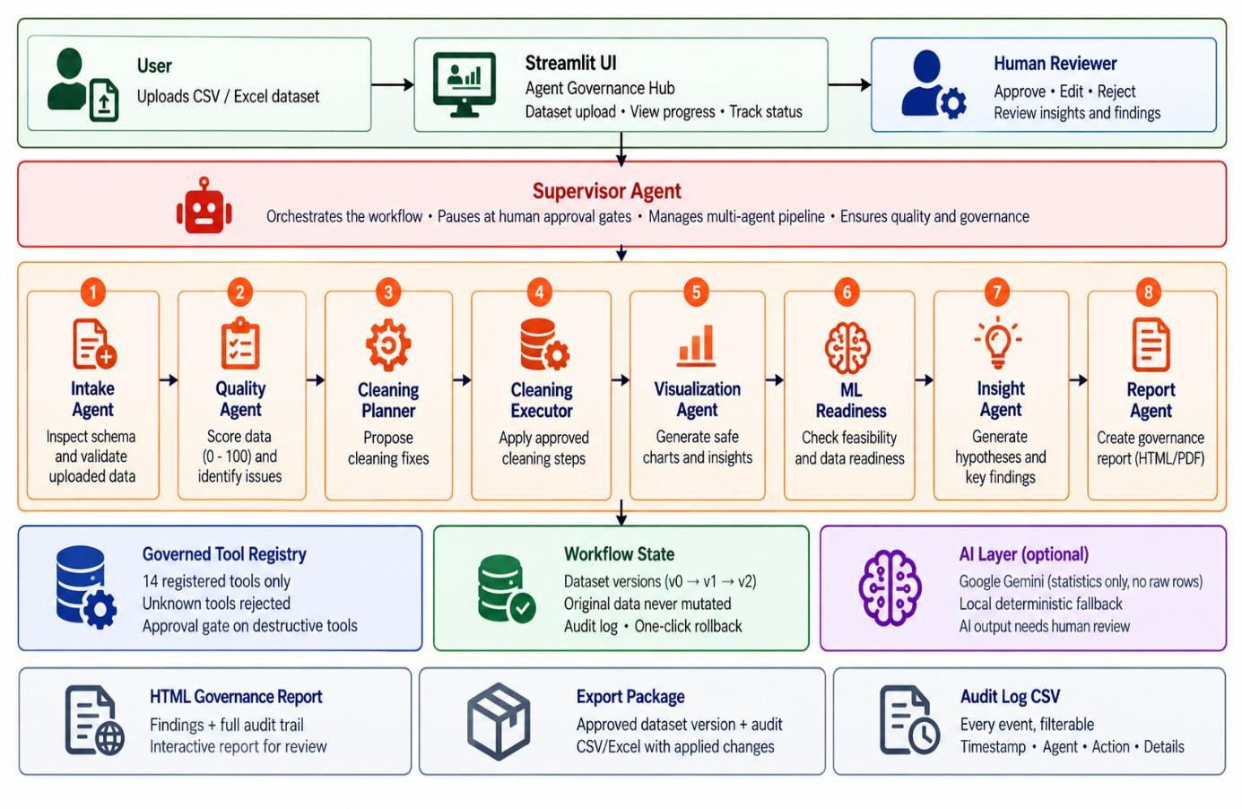

Figure 7.1: IntelliData Agent Architecture and Governance Flow

Agent Components Supervisor Agent
The Supervisor Agent is responsible for coordinating the complete workflow. It manages transitions between intake, quality analysis, cleaning, EDA, ML readiness, insight generation, and report generation.
It also stops the workflow at required approval checkpoints and uses a maximum step limit to prevent unwanted loops.

Intake Agent
The Intake Agent performs the initial inspection of the uploaded dataset. It checks the schema, duplicate column names, completely empty columns, suspicious identifier columns, and date-like strings.
The agent is read-only and does not modify the dataset.

Quality Agent
The Quality Agent evaluates the quality of the dataset using completeness, duplicate rate, type consistency, and IQR-based outlier checks. It produces a quality score between 0 and 100 and provides warnings about detected issues.

Cleaning Planner Agent
The Cleaning Planner Agent uses the quality findings to create cleaning proposals. Each proposal is assigned a risk level of low, medium, or high.
The agent does not directly change the dataset. The proposals must first be reviewed by the user.

Cleaning Executor Agent
The Cleaning Executor Agent performs only the cleaning actions that have been approved by the user. It uses registered deterministic tools and creates a new dataset version after a transformation the original dataset remains preserved.

Visualization Agent
The Visualization Agent examines the dataset and recommends suitable visualizations. It also applies semantic rules to prevent incorrect aggregations, such as summing ratings, percentages, or IDs.

ML Readiness Agent
The ML Readiness Agent checks whether the dataset is suitable for machine learning. It examines issues such as target leakage, class imbalance, feature scaling, and encoding requirements.

Insight Agent
The Insight Agent generates structured business hypotheses with confidence levels. The system is designed to avoid presenting correlation as causation.

Report Agent
The Report Agent collects the approved findings, dataset information, and audit trail and produces the final HTML governance report.

Tools
Agent capabilities are controlled through the Governed Tool Registry. The project contains 14 registered tools for tasks such as dataset validation, loading, profiling, quality assessment, EDA, cleaning, visualization recommendations, ML-readiness assessment, AI summaries, report generation, and export.
Agents cannot execute arbitrary LLM-generated code. Unknown tool names are rejected, and sensitive operations such as cleaning execution, rollback, and export require approval.

Memory and State
The workflow maintains its current state throughout execution. This state contains information about the active dataset, dataset versions, proposals, approvals, workflow progress, and audit events.
Dataset versioning provides a clear history of transformations through versions such as v0, v1, and v2. The original dataset remains preserved, while approved transformations are stored as new versions.

Reasoning Flow
The reasoning process follows the current workflow state rather than allowing an agent to perform unrestricted actions.
A simplified flow is:

Dataset Upload → Intake → Quality Analysis → Cleaning Proposal → Human Approval → Cleaning Execution → EDA/Visualization → ML Readiness → AI Insights → Human Review → Report and Export
At each important stage, the system uses the findings from the previous stage to determine the next workflow action. Approval checkpoints ensure that consequential actions remain under human control.

Agent Interactions
The agents interact through the Supervisor Agent and shared workflow state rather than operating independently.
For example, the Quality Agent identifies data issues and provides its findings to the Cleaning Planner Agent. The planner converts these findings into proposals. After human approval, the Cleaning Executor applies the approved actions. The resulting dataset version is then used by the downstream Visualization, ML Readiness, and Insight Agents.

Agent Workflow and Orchestration

Workflow Design
The IntelliData workflow is designed as a sequence of coordinated agent stages controlled by the Supervisor Agent. The workflow begins when the user uploads a dataset or opens the sample workspace.
The main workflow is:
Dataset Upload → Intake & Quality → Cleaning Planning → Human Approval → Cleaning Execution → Visualization & EDA → ML Readiness
→ Insight Generation → Human Review → Report and Export
The Supervisor Agent manages these transitions and pauses the workflow whenever human approval is required. A maximum-step limit is also used to prevent unwanted workflow loops.

Task Decomposition
The complete data intelligence task is divided into smaller tasks so that each agent has a clear responsibility.
    - Dataset Intake – Inspect and validate the dataset structure.
    - Quality Assessment – Identify data quality issues and calculate the quality score.
    - Cleaning Planning – Convert quality findings into risk-rated cleaning proposals.
    - Human Approval – Allow the user to approve, edit, or reject proposals.
    - Cleaning Execution – Apply only approved transformations.
    - EDA and Visualization – Analyze distributions, correlations, and recommend suitable charts.

    - ML Readiness – Check machine learning requirements and risks.
    - Insight Generation – Generate structured AI hypotheses.
    - Human Review – Review AI-generated insights before export.
    - Report Generation and Export – Prepare the final governance report and approved dataset package.
This decomposition keeps each stage focused and makes the overall workflow easier to control.

Agent Coordination
The Supervisor Agent coordinates the specialized agents using the current workflow state.
For example, after the Quality Agent completes its analysis, the Cleaning Planner Agent uses those findings to create proposals. The workflow then moves to the approval stage instead of immediately executing the proposed changes.
After approval, the Cleaning Executor Agent applies the approved actions and creates a new dataset version. The updated dataset is then passed to the downstream intelligence stages.
This coordination ensures that agents work as parts of one connected workflow rather than as independent features.

Orchestration Implementation
The orchestration is implemented using a workflow state machine with defined stages and approval checkpoints. The project uses a Supervisor Agent along with specialized agents to manage these transitions.
The workflow includes states such as:
- Intake

- Quality
- Cleaning plan
- Waiting for cleaning approval
- Cleaning execution
- Visualization and EDA

- ML readiness
- Insight generation
- Waiting for insight review
- Report generation

- Waiting for export approval
- Completed

When a proposal requires approval, execution is blocked until the user provides a decision. Approved actions are then executed through the Governed Tool Registry.
The tool registry prevents agents from directly executing arbitrary code. Sensitive operations such as execute cleaning, rollback cleaning, and export dataset require valid approval before they can be performed.

Agentic RAG Implementation

Retrieval Architecture
IntelliData uses dataset-derived information and governance information as knowledge sources during the agent workflow. The system derives useful information from the active dataset, including column profiles, cardinality, missing percentages, quantiles, IQR outliers, distributions, and Pearson correlations.
This information is used by the agents to support quality assessment, EDA, ML-readiness analysis, and AI-generated hypotheses. Governance information such as cleaning proposals, approval decisions, dataset versions, and audit events is also maintained as part of the workflow state.
The project documentation does not specify a separate vector database or conventional document-based RAG pipeline. Therefore, the implemented knowledge flow is described here in terms of retrieval and use of dataset-derived statistical and governance information, rather than claiming a vector-based RAG system.

Knowledge Retrieval
During the workflow, agents use the information produced by earlier stages. For example, the Quality Agent produces quality findings that are used by the Cleaning Planner Agent to create cleaning proposals.
Similarly, statistical information such as distributions and Pearson correlations is used by the Insight Agent to generate structured hypotheses. The ML Readiness Agent uses dataset characteristics to identify issues such as target leakage, class imbalance, scaling, and encoding requirements.
This allows the agents to work with information relevant to the current dataset instead of relying only on general AI responses.

Generation Process
When Gemini is available, the system uses bounded statistical information to generate executive summaries and structured hypotheses. The project maintains a privacy boundary in which zero raw dataset rows are sent to Gemini. Inputs are also sanitized before being used in AI prompts.
The generated output is treated as a hypothesis rather than a confirmed fact. The Insight Agent uses confidence levels and does not make causal claims from correlation.
When Gemini is unavailable, IntelliData uses a local deterministic fallback based on Pearson correlations. This allows the workflow to continue without depending completely on an external AI service.

Retrieval-Quality Evaluation
The current project focuses on the quality and usefulness of the information derived from the dataset rather than reporting a separate RAG retrieval score.
The main checks are whether the system correctly derives relevant statistics, uses appropriate information for each agent, and produces structured outputs without exposing raw records. The generated AI hypotheses are also subject to human review before final export.
Therefore, retrieval quality in the current implementation is evaluated through the correctness and relevance of the derived dataset information and the resulting agent outputs, rather than through a standalone vector-retrieval metric.

System Implementation

Functional Prototype
The IntelliData prototype is implemented as a Streamlit-based multi-page application. The main interface provides dataset upload, workflow controls, data analysis, approval controls, and access to the Agent Governance Hub. Streamlit is used as the main application framework for the user interface.
The functional prototype supports the complete workflow from dataset intake to report generation. Users can upload a CSV or Excel dataset and start the autonomous pipeline. The system then performs intake and quality analysis before creating cleaning proposals.
The main functional stages of the prototype are:

    - Dataset Upload – Upload a CSV or Excel dataset or open the sample workspace.
    - Agent Governance Hub – Start and monitor the autonomous pipeline.
    - Data Quality Analysis – View quality scores and detected issues.
    - Cleaning Proposal Review – Review risk-rated proposals.
    - HITL Approval – Approve, reject, or edit proposed actions.
    - Cleaning Execution – Execute approved transformations and create a new dataset version.
    - EDA and Visualization – View distributions, correlations, and recommended charts.
    - ML Readiness – Review machine learning feasibility and identified risks.
    - AI Insights – Review structured business hypotheses.

    - Report and Export – Authorize and generate the final governance package.
The approval interface provides individual approval and rejection controls, parameter editing, batch selection, high-risk confirmation, and contextual explanations for proposals.

Source-Code Repository
The project is maintained as a Python-based application with separate components for agents, workflow management, tools, user interface, and supporting modules.
The main implementation areas include:
- Agents – Specialized agents responsible for different workflow stages.

- Workflow – State management and Supervisor Agent orchestration.
- Tools – Registered deterministic tools used by agents.
- UI – Streamlit pages and governance controls.
- Modules and Utilities – Data processing, AI services, logging, and supporting functions.
- Tests – Unit and governance tests used to verify system behavior.

The project also includes development checks using pytest, Ruff, and pip check, along with Docker and GitHub Actions for containerized deployment and continuous integration.

Prototype Screenshots
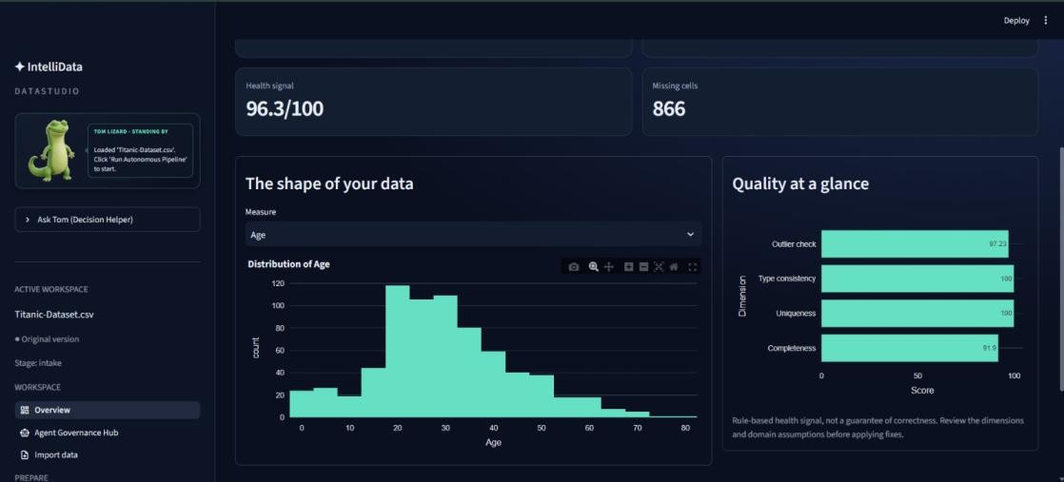

Figure 10.1: Data Quality Assessment and Dataset Distribution
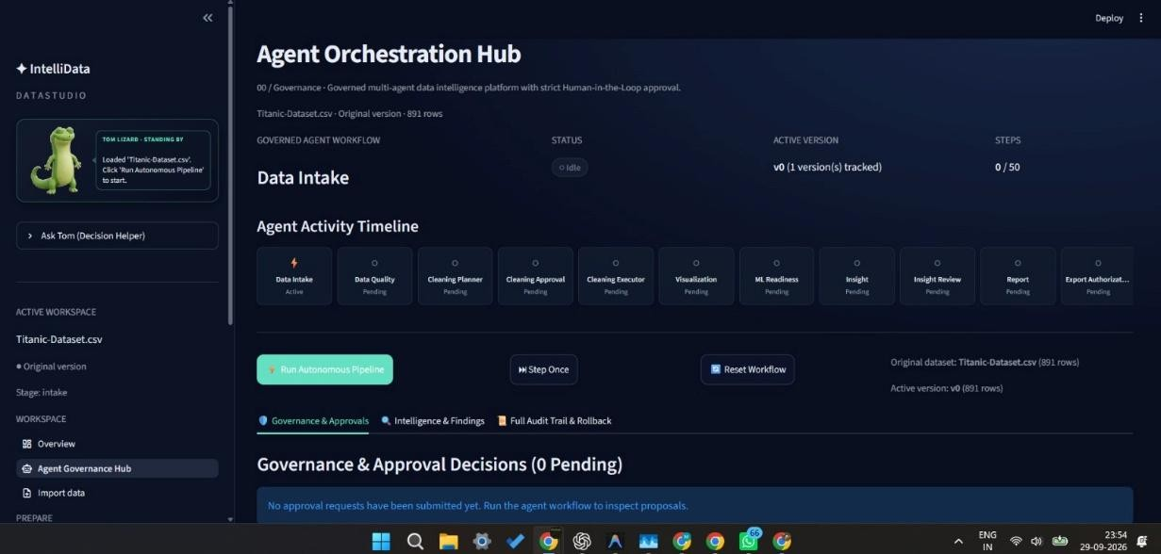

Figure 10.2: Agent Governance Hub and Multi-Agent Workflow
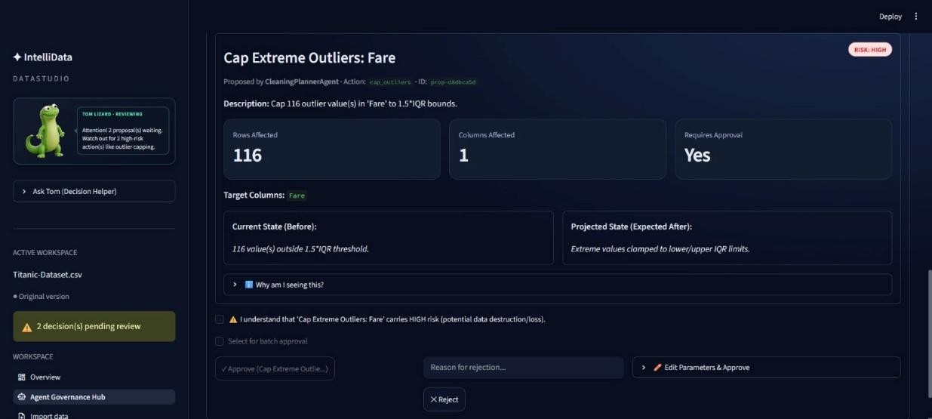

Figure 10.3: Human-in-the-Loop Review of a High-Risk Cleaning Proposal

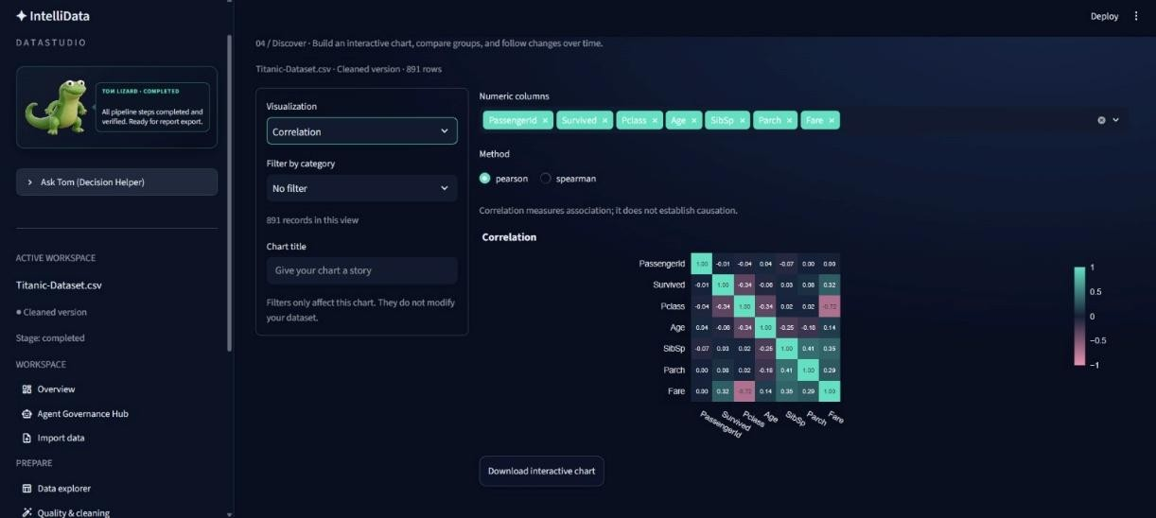

Figure 10.4: Interactive Visualization and Correlation Analysis
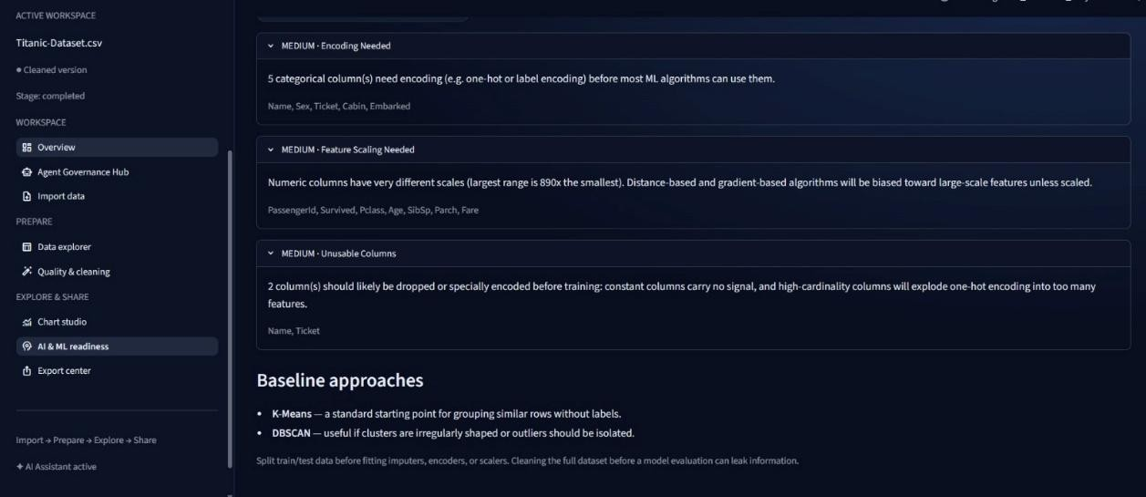

Figure 10.5: ML Readiness Assessment and Baseline Recommendations
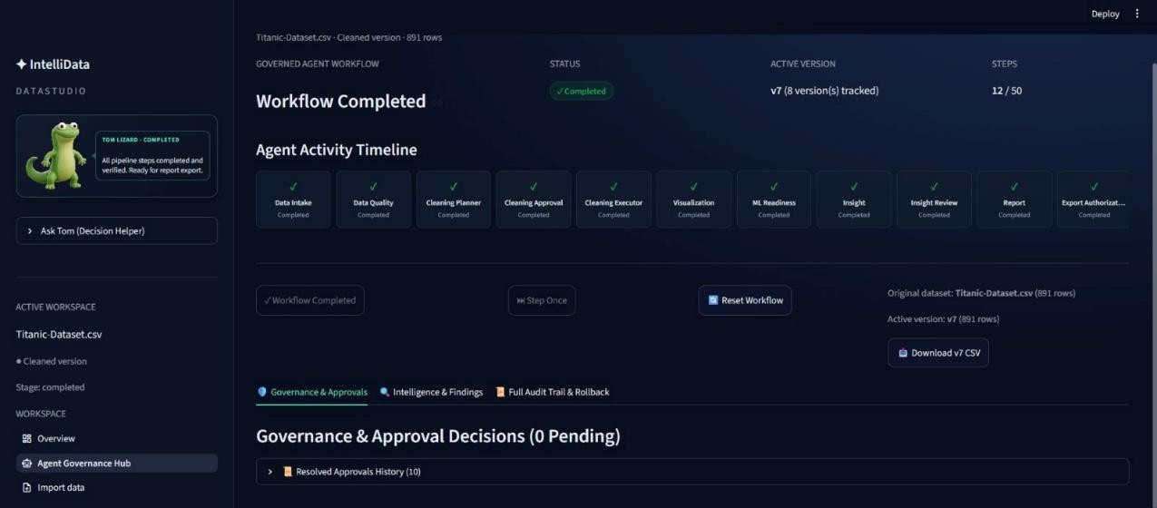
Figure 10.6: Completed Agent Workflow with Dataset Version Tracking

Experimental Evaluation and Results

Evaluation Metrics
The IntelliData system was evaluated based on the main objectives of the project. The evaluation focuses on functional correctness, governance, human approval, data versioning, privacy, and workflow completion.
The main evaluation areas are:
- Workflow correctness – The Supervisor correctly coordinates the agents and workflow states.
- Tool governance – Only registered tools can be executed.
- HITL control – Sensitive actions stop for human approval before execution.
- Data versioning – Cleaning creates a new dataset version while preserving the original dataset.
- Auditability – Important workflow and approval events are recorded in the audit trail.
- AI privacy – Raw data rows are not sent to the AI service.

- Fallback handling – The system continues with a deterministic local fallback when Gemini is unavailable.
- Report generation – Approved results and audit information can be compiled into the governance report.
These evaluation areas directly reflect the project's governance and human-control requirements.

Testing Methodology
Testing was performed using automated tests and end-to-end workflow checks. The project uses pytest for testing and Ruff for code-quality checks. The project plan also includes governance-focused tests covering important approval and execution behavior.
The end-to-end evaluation follows the main user journey:
Dataset Upload → Intake → Quality → Cleaning Planning → Human Approval → Cleaning Execution → EDA → ML Readiness → AI Insights → Human Review → Report and Export
Special attention was given to approval-required operations, rejected actions, edited parameters, high-risk cleaning actions, version creation, rollback, and export authorization.

Performance Results
The prototype successfully demonstrates the complete agent workflow from dataset upload to the final governance report. The Supervisor coordinates the specialized agents and pauses the workflow at defined approval checkpoints.
The implemented system also demonstrates that:

- Unregistered tools are rejected.
- Cleaning actions are not executed without approval.
- Approved cleaning operations create new dataset versions.
- The original dataset remains preserved.

- AI-generated insights are presented for human review.

- Export requires explicit authorization.
- The system can use a local deterministic fallback when the optional Gemini service is unavailable.
No separate numerical benchmark for response time, model accuracy, or RAG retrieval quality is specified in the project materials. Therefore, the evaluation focuses on functional and governance behavior rather than introducing unsupported numerical results.

Success-Metric Achievement
The project objectives are addressed through the implemented workflow and governance controls. The system provides automated data profiling, quality assessment, controlled cleaning, EDA, ML-readiness analysis, human-reviewed AI insights, versioning, audit tracking, and controlled report export.
Overall, the evaluation confirms that the prototype implements the planned Agentic AI workflow with Human-in-the-Loop governance, rather than relying on fully automatic data modification or analysis.

Comparison, Innovation and Scalability

Comparison with Baseline
The proposed IntelliData platform can be compared with a conventional manual data-analysis workflow.

Aspect | Conventional Workflow | IntelliData
Data profiling | Manually performed | Automated by Intake and Quality Agents
Cleaning | Manual or directly automated | Proposed by AI and executed after approval
EDA | Analyst-driven | Supported by Visualization Agent
ML readiness | Manually checked | ML Readiness Agent
AI insights | Separate analysis step | Integrated through Insight Agent
Human control | Depends on the process | Built into approval checkpoints
Versioning | May require manual tracking | Dataset versions and rollback
Audit trail | Often maintained separately | Integrated into the workflow
Export | Normal file export | Requires explicit authorization

The main difference is that IntelliData combines data analysis with agent orchestration and governance. The system does not allow sensitive actions to proceed without the required human approval.

Advantages of the Proposed System
The main advantages of IntelliData are:

- Reduces repetitive data preparation work.
- Divides the workflow into specialized agents.
- Keeps humans involved in important decisions.
- Preserves the original dataset through versioning.
- Provides rollback for cleaning operations.

- Maintains an audit trail of important actions.
- Prevents arbitrary tool execution.
- Protects raw data when using AI services.
- Combines data quality, EDA, ML readiness, and AI insights in one workflow.

Innovation

The key innovation of the project is the combination of Agentic AI, governed tool execution, Human-in-the-Loop approval, and immutable data versioning in a single data intelligence workflow.
Instead of allowing an AI system to directly modify data, IntelliData separates proposal, human approval, execution, and auditing. This provides a controlled approach to using AI for data preparation and analysis.

Scalability
The architecture is designed around a Supervisor Agent and specialized agents. This separation allows individual workflow responsibilities to remain independent and makes it possible to extend the platform with additional agents or registered tools without changing the complete workflow structure.
The use of a Tool Registry also provides a controlled way to add supported operations while rejecting unknown tools.

Real-World Applicability
The system can support Data Analysts and Scientists, Business Users and Decision Makers, and Students and Researchers. It is particularly useful where datasets require repeated preparation and where changes need to remain reviewable and traceable.
The governance approach also makes the platform suitable for workflows where human review, version history, and audit information are important parts of the analysis process.

Conclusion and Future Work

Conclusion
IntelliData demonstrates an Agentic AI based Data Intelligence & Governance Platform for controlled and explainable data analysis. The system uses a Supervisor Agent and specialized agents to automate dataset intake, quality assessment, cleaning planning, cleaning execution, visualization, ML readiness, insight generation, and report generation.
A key part of the system is Human-in-the-Loop governance. Cleaning and export actions are not allowed to proceed without the required approval. Dataset versioning, rollback, and audit tracking provide additional control over changes made during the workflow.
The project also addresses AI privacy by using bounded statistical information instead of sending raw data rows to the AI service. When Gemini is unavailable, the system provides a local deterministic fallback.
Overall, the project shows how Agentic AI can be used to reduce repetitive data-analysis work while keeping human control, data versioning, tool governance, and auditability as core parts of the system.

Future Work
The current project provides a working foundation that can be extended in future versions. Possible future improvements include:
- Support for additional dataset formats and larger datasets.
- More specialized agents for advanced data-analysis tasks.
- Additional registered tools for data preparation and analysis.
- More advanced AI-assisted insight generation.
- Expanded evaluation datasets and performance measurements.

- Additional deployment and integration options.
- Further improvements to the user interface and governance reporting.
These improvements can extend the platform while keeping the existing Supervisor, Tool Registry, Human-in-the-Loop approval, versioning, and audit structure as the foundation.

REFERENCES

    - S. Yao, J. Zhao, D. Yu, N. Du, I. Shafran, K. Narasimhan, and Y. Cao, “ReAct: Synergizing Reasoning and Acting in Language Models,” arXiv preprint arXiv:2210.03629, 2022.
    - P. Lewis, E. Perez, A. Piktus, F. Petroni, V. Karpukhin, N. Goyal, H. Küttler, M. Lewis, W. Yih, T. Rocktäschel, and D. Kiela, “Retrieval-Augmented Generation for Knowledge-Intensive NLP Tasks,” arXiv preprint arXiv:2005.11401, 2020.
    - X. Wu, L. Xiao, Y. Sun, J. Zhang, T. Ma, and L. He, “A Survey of Human-in-the-loop for Machine Learning,” Future Generation Computer Systems, vol. 135, pp. 364–381, 2022.
    - E. Mosqueira-Rey, E. Hernández-Pereira, D. Alonso-Ríos, J. Bobes-Bascarán, and Á. Fernández-Leal, “Human-in-the-loop machine learning: a state of the art,” Artificial Intelligence Review, vol. 56, pp. 3005–3054, 2023.
    - N. Sambasivan, S. Kapania, H. Highfill, D. Akrong, P. Paritosh, and L. M. Aroyo, “Everyone wants to do the model work, not the data work: Data Cascades in High-Stakes AI,” in Proceedings of the CHI Conference on Human Factors in Computing Systems, 2021.
    - Google, “Gemini API Documentation,” Google AI for Develop.

